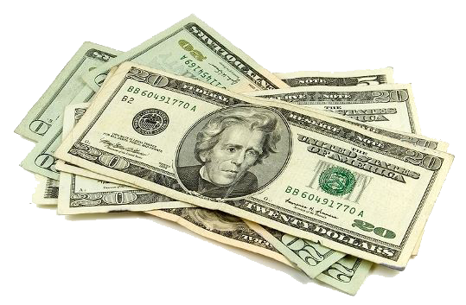
REDUCED TUITION!

Would you like your tuition or daycare costs reduced? By participating in the SCRIP program, you can!

What is SCRIP?
SCRIP is a gift card program where you buy gift cards at face value and get a percentage of your purchase toward tuition or daycare.

Why use your bank or credit card for “pay-at-the pump” or online purchases that are not secure? Instead, you can use a gift card and know that your personal bank or credit card information is secure. And even better, you begin accumulating credit to be used towards next year’s tuition! Some of our families are already saving over $500 in tuition just by using the SCRIP program.

Here is an example:
The average family of 4 spends about $600 per month on groceries ($7,200 per year). Our local grocery stores offer 3% credit which means you would get $162 off of your next years’ tuition! And adding gas, eating out, online shopping….the possibilities are endless! See the back for local participating vendors.

Ask your family and friends to do the same thing and apply their credit to your family. What an amazing gift they can give to your child(ren)!

SCRIP can be purchased through the school office, Parish Center or back of church after weekend Masses. If your order contains items that are not in stock, they will be ordered and arrive in about a week.

If you are in a hurry, you can download the RaiseRight Mobile App on your smartphone and set up an online account. This is best for reloadable or e-cards.

So what are you waiting for?

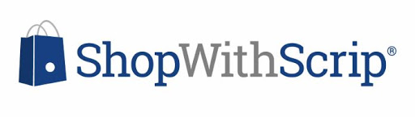

PARTICIPATING SCRIP VENDORS

Local Vendors  Gas  BP (1.5%)  Sunoco (2%)  Grocery  Piggly Wiggly (3%)  Pick N Save (4%)  Loehr’s (5%)  Restaurants  Ala Roma/Schmitty’s (5%)  Backyard Grill (FDL) (5%)  Crave (8%)  Diner 67 (5%)  Eden Café (3%)  Friar/Salty/Sebastian’s (5%)  Gilles Fond du Lac (10%)  King Pin (6%)  Other  Fire Bug (17%)  True Value (5%)  Dr. Dean Uelmen (3%)  Flood Oil (2%)  Herriges (2%) | Fan Favorites  Gas  Kwik Trip (4%) R  Mobil/Exxon (1%) R  Grocery  Festival (3%)  Meijer (3%) R  Pick N Save (4%)  Sendik’s (4%) R  Restaurants  Applebees (8%)  Buffalo Wild Wings (8%) R, E  Culvers (8%)  Dairy Queen (3%)  McDonald’s (5%)  Noodles & Company (8%)  Panera Bread (8%) R, E  Pizza Ranch (8%) E  Qdoba (7%)  Subway (4.5%) R, E  Other  Amazon (1.7%) E  Bath & Body Works (12%) R, E  Cabela’s (10%) E  Fleet Farm (3.5%)  Gap/Old Navy (14%) R, E  Home Depot (4%) R, E  Kohls (4%) E  Menards (3%)  Target (2.5%) R, E  VISA (1.25%)  Walmart (2.5%) R, E
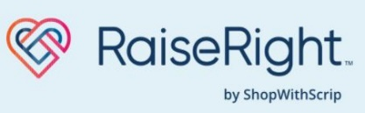
R = Reloadable
E = e-card

